Self Service Password Reset Employee Guide

Step 1: Navigate to the Password Rest Portal
- Open Microsoft Edge
- Navigate to the following link: https://aka.ms/sspr

Step 2: Verify Your Identity
- Enter your DC. Gov email in the 1st field
- Enter the Captcha that is displayed in the 2nd field
- Select Next.
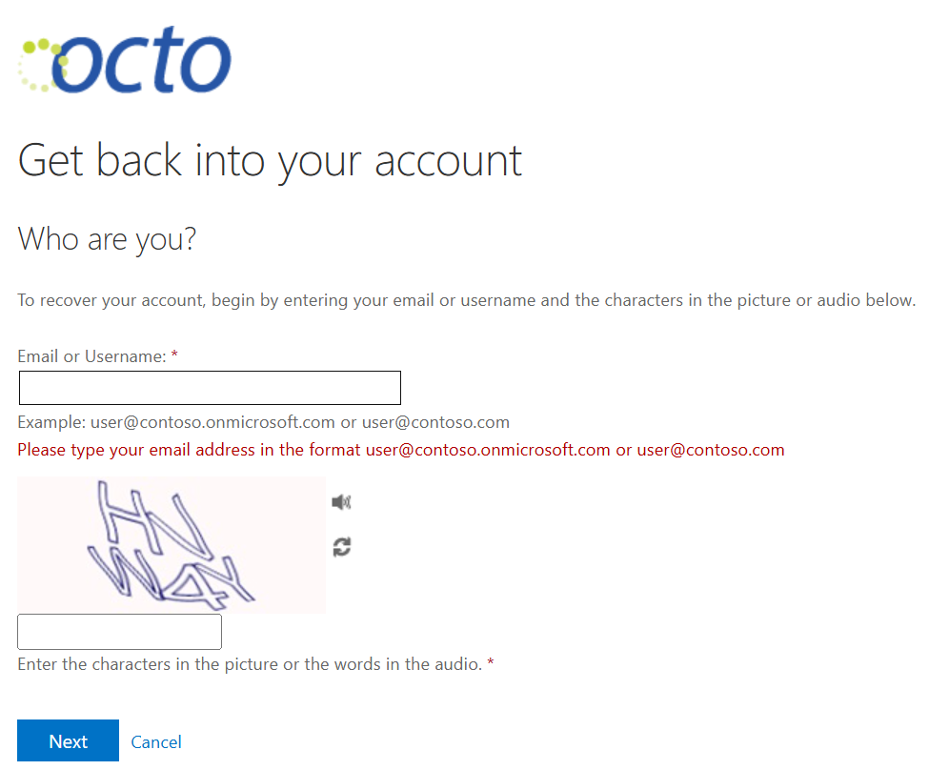

Step 3: Enter Verification Code
- Choose one of the verification options
- Retrieve the code sent via your selected method
- Enter the code in the verification field
- Select next
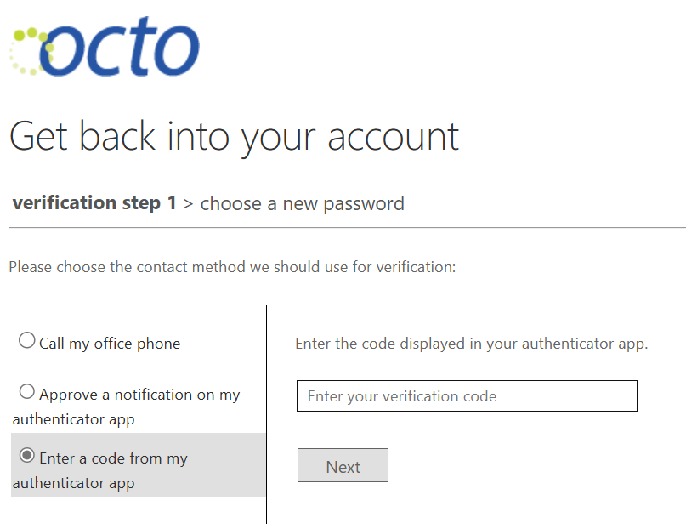

Step 3: Using the Authenticator App
- Navigate to the Authenticator app on your mobile device 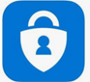
- Enter the number shown to approve sign in
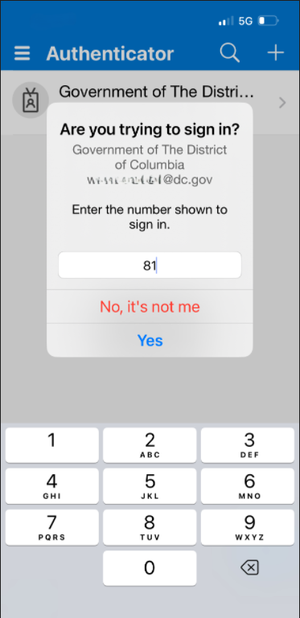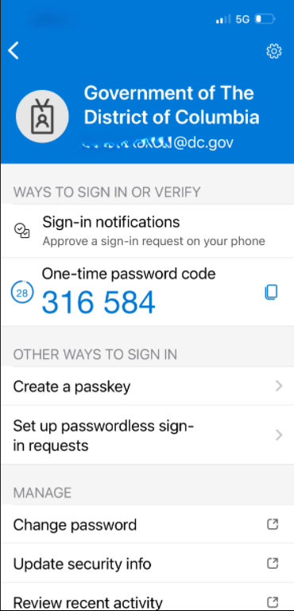
Approve a notification on my authenticator app Enter a code from my authenticator app

*If your desk phone or your mobile phone number are in the system, you will also have the option to have a text sent to you or receive a call

Step 4: Create a new Password:
- Enter a new password that meets the organizations requirements:
- Re-enter the new password to confirm
- Select finish
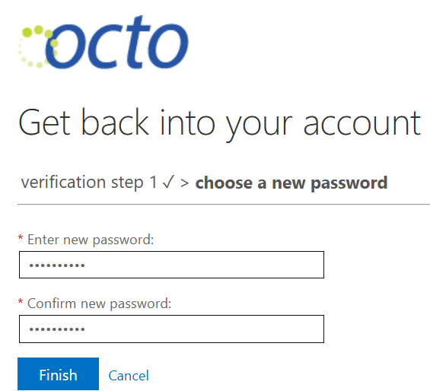

- A confirmation email will be sent when your password has been successfully reset.

Please Call DOES OIT if you have any issues or questions.

